Name: Sergio Gutierrez

bitbucket Repo: <https://bitbucket.org/SergioZGutierrez/homework/src/master/>

Exercise 3 (there’s two exercises/apps, within exercise 3).

Part 1, First App Output:

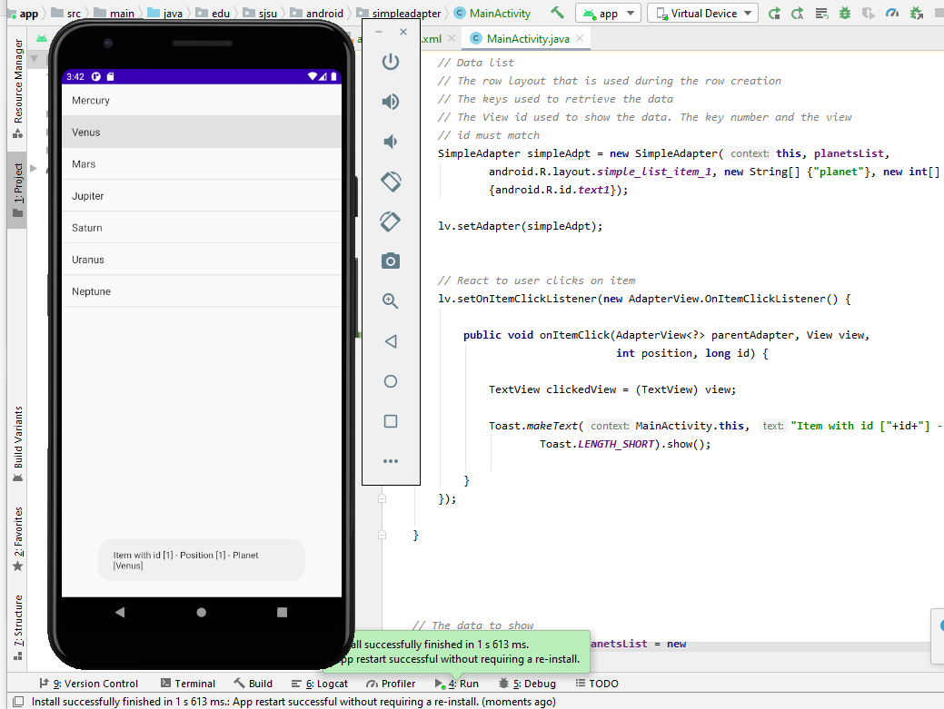

Part 2, Second App output:

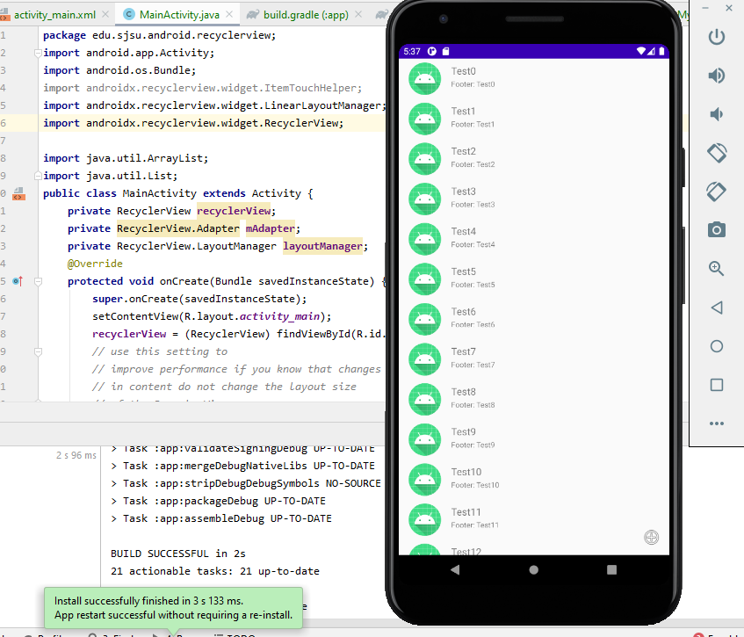

The exact pathways of where the .java files are located in my repository are:

<https://bitbucket.org/SergioZGutierrez/homework/src/master/SimpleAdapter/app/src/main/java/edu/sjsu/android/simpleadapter/>

and:

<https://bitbucket.org/SergioZGutierrez/homework/src/master/RecyclerView/app/src/main/java/edu/sjsu/android/recyclerview/>

Or, you can simply look up these two folders:

